Corrosion Process

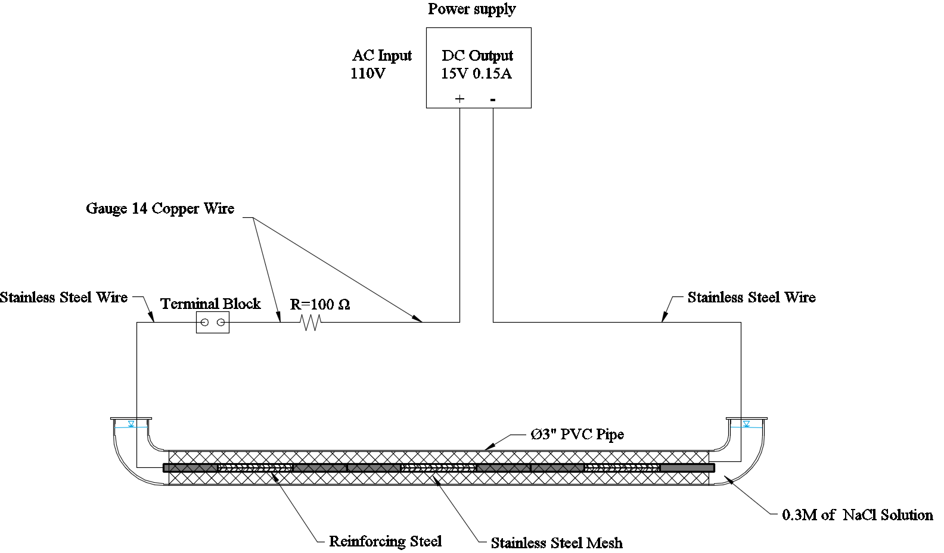

Tension tests

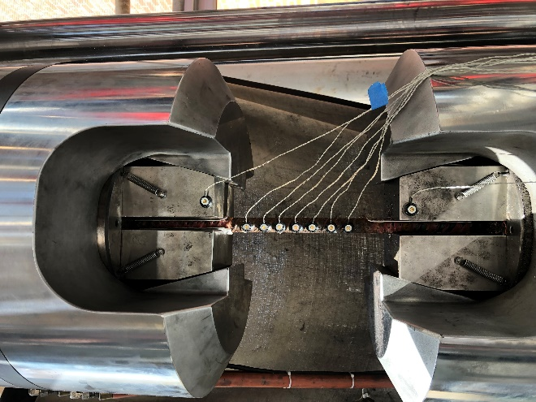

BBT tests

|  |  |  |
| --- | --- | --- |
|  |  |  |
| 1. Test setup | 1. Bar loaded in UTM | 1. Buckled bar in compression |
|  |  |  |

|  |  |
| --- | --- |
| C:\ConditionDependentPBEE\Thesis\VAC Thesis 2.0\Chapter-4\figs\BBT_Brittle.JPG | C:\ConditionDependentPBEE\Thesis\VAC Thesis 2.0\Chapter-4\figs\BBT_Ductile.JPG |
| 1. Brittle failure | 1. Ductile failure |

3D Scans

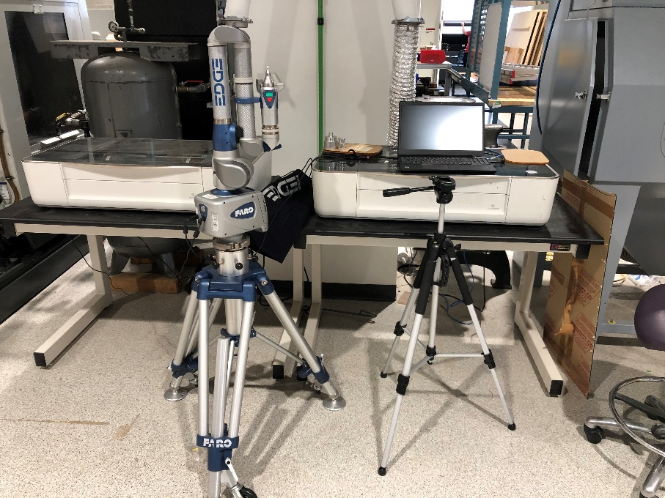

SEM

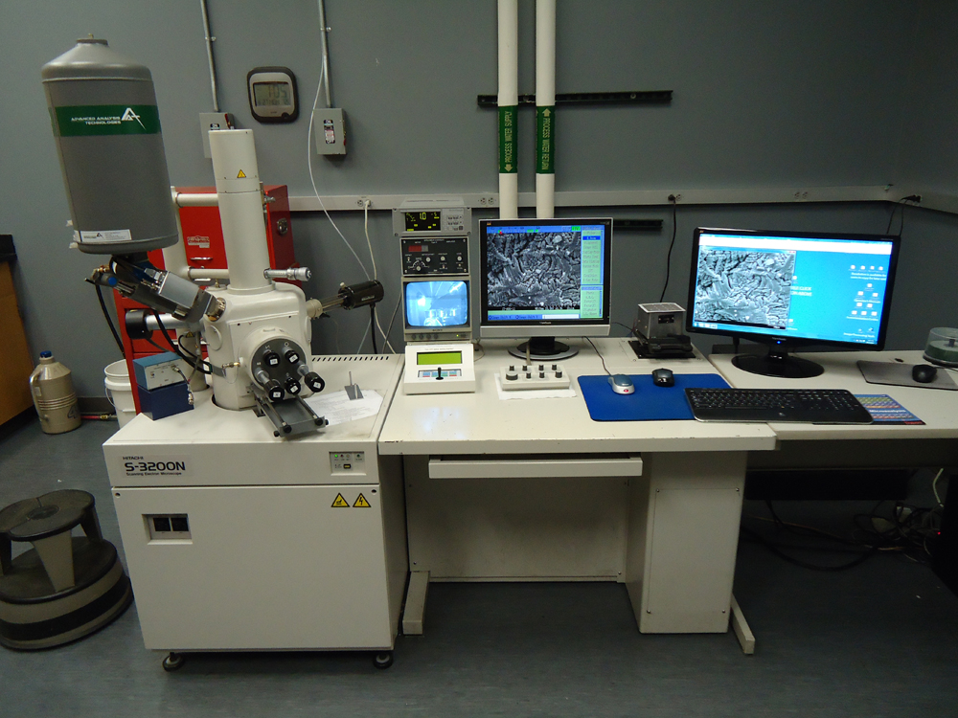

Turned down bar

